Create React App doesn't include page routing.
React Router is the most popular solution.

Add React Router
To add React Router in your application, run this in the terminal from the root directory of the application:
npm i -D react-router-dom
Note: Using React Router v6.
If you are upgrading from v5, you will need to use the @latest flag:
npm i -D react-router-dom@latest

Folder Structure
To create an application with multiple page routes, let's first start with the file structure.
Within the src folder, we'll create a folder named pages with several files:
src\pages\:
- Layout.js
- Home.js
- Blogs.js
- Contact.js
- NoPage.js
Each file will contain a very basic React component.
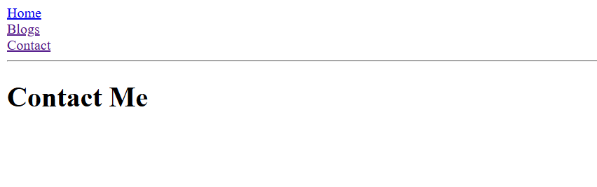
Basic Usage
Now we will use our Router in our index.js file.
Use React Router to route to pages based on URL:
index.js:
import ReactDOM from "react-dom/client";
import { BrowserRouter, Routes, Route } from "react-router-dom";
import Layout from "./pages/Layout";
import Home from "./pages/Home";
import Blogs from "./pages/Blogs";
import Contact from "./pages/Contact";
import NoPage from "./pages/NoPage";

export default function App() {
return (
<BrowserRouter>
<Routes>
<Route path="/" element={<Layout />}>
<Route index element={<Home />} />
<Route path="blogs" element={<Blogs />} />
<Route path="contact" element={<Contact />} />
<Route path="*" element={<NoPage />} />
</Route>
</Routes>
</BrowserRouter>
);
}

const root = ReactDOM.createRoot(document.getElementById('root'));
root.render(<App />);
Example Explained
We wrap our content first with <BrowserRouter>.
Then we define our <Routes>. An application can have multiple <Routes>. Our basic example only uses one.
<Route>s can be nested. The first <Route> has a path of / and renders the Layout component.
The nested <Route>s inherit and add to the parent route. So the blogs path is combined with the parent and becomes /blogs.
The Home component route does not have a path but has an index attribute. That specifies this route as the default route for the parent route, which is /.
Setting the path to * will act as a catch-all for any undefined URLs. This is great for a 404 error page.
Pages / Components
The Layout component has <Outlet> and <Link> elements.
The <Outlet> renders the current route selected.
<Link> is used to set the URL and keep track of browsing history.
Anytime we link to an internal path, we will use <Link> instead of <a href="">.
The "layout route" is a shared component that inserts common content on all pages, such as a navigation menu.
Layout.js:
import { Outlet, Link } from "react-router-dom";

const Layout = () => {
return (
<>
<nav>
<ul>
<li>
<Link to="/">Home</Link>
</li>
<li>
<Link to="/blogs">Blogs</Link>
</li>
<li>
<Link to="/contact">Contact</Link>
</li>
</ul>
</nav>

<Outlet />
</>
)
};
export default Layout;

file name : right click pages folder -> new file and name is as Home.js:
Home.js
const Home = () => {
return <h1>Home</h1>;
};

export default Home;
file name : right click pages folder -> new file and name is as Blog.js:

Blogs.js:
const Blogs = () => {
return <h1>Blog Articles</h1>;
};

export default Blogs;
file name : right click pages folder -> new file and name is as Contact.js:

Contact.js:
const Contact = () => {
return <h1>Contact Me</h1>;
};

export default Contact;

file name : right click pages folder -> new file and name is as NoPage.js:

NoPage.js:
const NoPage = () => {
return <h1>404</h1>;
};
export default NoPage;

